

Admissions Policy

Name of the Owner: Karim Murcia
Name of the Author: Ann Philip
Date of Last Review: 19.05.2026
Date of Next Review: 19.05.2027

Introduction
We believe this policy should be a working document that is fit for purpose and represents the school ethos enabling consistency and quality across the school.
We will consider all applications for admission as we are an inclusive school and will admit students without reference to general ability or aptitude. We believe we operate a fair and equal admissions policy.
We as a school community have a commitment to promote equality. Therefore, an equality impact assessment has been undertaken, and we believe this policy is in line with equality expectations.
We believe it is essential that this policy clearly identifies and outlines the roles and responsibilities of all those involved in the procedures and arrangements that relates with this policy.

Our Aim
To establish and maintain a fair and open admissions policy.

Role of the Heads and Senior Leadership Team
The Heads and the Senior Leadership Team will:
  - ensure all school personnel, students and parents are aware of and comply with this policy;
  - work closely with the policy owner;
  - provide leadership and vision in respect of equality;
  - make effective use of relevant research and information to improve this policy;
  - provide guidance, support and training to all staff;
  - annually report to the Board of Governors on the success and development of this policy.

Role of Parents/Caregivers will:
  - be aware of and comply with this policy;
  - apply by using the appropriate application form;

Raising Awareness of this Policy
We will raise awareness of this policy via:
  - the school website
  - the Staff Handbook
  - meetings with parents such as introductory, transition, parent-teacher consultations
  - school events
  - meetings with school personnel
  - communications with home such as newsletters
  - information displays in the main school entrance

Policy Content
The medium of instruction throughout the Reigate Grammar School is English, and it is a requirement of admission that children have a good understanding of English. However, the school provides English as an Additional Language (EAL) for students requiring additional support to be proficient in the language.
Applications will be accepted for any place that the school anticipates being available. Before being offered a place, all applicants for admission to the school, of whatever nationality and in whatever category, must satisfactorily complete the school admission process. Children are invited for interviews/placement assessment only when a place becomes available either on roll or within waitlist parameters.
If an assessment is required for placement, the school will evaluate the student’s English language proficiency, academic potential and social behaviour. It might involve a range of testing procedures including an interview and or a written assessment according to the age of the applicant. Depending upon the results of the assessment, an offer of a place may be made. Parents will be advised of the decision within three working days of the completion of the interview/assessment.
If applications are received for Year 10/11 or 12/13 (i.e., for IGCSE and A level courses) for entry after the first eight weeks of the programme, the school will consider each case individually and decide about entry based on continuity of courses, subject availability, assessment components missed, realistic expectations of the student and their parents and the likelihood of the student achieving their academic potential.

Wait List Guidelines

Priority 1 Children
A child who has a sibling already enrolled and for whom a class place is not immediately available will be placed on a waitlist if his/her parents so desire.
The child’s position on the waiting list will be chronological to the date of his/her application being submitted to the registrar.
The parents will be advised of the number of children, if any, who are ahead of their child on the waiting list for that year.
At the end of each school year, the parents of any child remaining on the waiting list will be contacted to establish whether they would like their child(ren) to remain on the waitlist for the following academic year.
The Heads of Schools will have discretion to decide, at the end of Semester 2, whether to release some or all of the Priority Group 1 reserved places in order to accommodate Priority Group 2 children who are on a wait list or who would otherwise be on a wait list
Application for Priority Group 1 and Priority Group 2 children may be submitted at any time during the school year.

Priority 2 Children
A child on the waiting list is in the priority 2 group. The child’s position on the waiting list will be chronological to the date of his/her application.
Parents will be advised of the number of children, if any, ahead of their child on the wait list. They will also be advised that Priority Groups 1 children could pre-empt an available place.
At the end of each school year, the parents of any child remaining on the wait list will be contacted to establish whether their child should remain on that list.

The Application Procedure
The following information will be available for prospective parents:
‘Thank you for your interest in the RGSR and for your enquiry for the admission of your son or daughter. To be considered for entry, please complete the Registration Form and submit, along with other documentation requested, to the Registrar. The completion of the form does not guarantee admission.’
Priority is given to children in line with the admission policy listed above. Children are scheduled for assessment when a place becomes available and, if successful, allocated to a year group.
Children are assessed and, if successful, placed in year groups appropriate to their chronological age i.e. age- appropriate birthday between 1st September and 31st August.
For students applying for a place parents must submit:
  - Completed registration form
  - Copy of Child’s passport
  - All school reports at current school for the past year
  - Completed medical form
  - Application fee
A copy of the father’s and mother’s/carer’s Iqama and passport will be required prior to enrolment.
The Application fee will be refunded if the child is not admitted to the school after one full calendar year following the date of initial application.
Admission to Reigate Grammar School is conditional upon parental agreement that students will participate fully in the curriculum and related activities.

The Admissions Process
Once the application form, copies of school reports, medical form, passport details and fee have been submitted, the Registrar will schedule an interview/entry assessment according to the Priority list above.
The admission will be based on the following criteria:
  - If a student is being registered in a school for the first time, the child will be placed in the appropriate age group (Year level) as listed in the chart.

  - When a student’s last report clearly indicates the grade or year level, he/she has attended, then this should be given priority over the age factor. The coordinator/HoD for that area needs to be informed about the admission and if there are concerns, the student needs to appear for a placement test.
  - If a student has no previous report and is age appropriate for a particular class, the HoD for the area must be consulted and a placement test might be required.
  - If a student appears to have learning difficulties or special needs, the registrar will refer the student to the SEN department. The SEN department will decide whether it can accept the student based on the facilities available.
The Registrar will inform parents of the outcome of the interview/assessment within three working days. A conditional place may be offered subject to the submission of the parents Iqama and payment of all fees and deposits. No child may start at the school until all documentation, fees and deposits have been submitted.
If subsequent to enrolment, the school believes that a child cannot benefit from the curriculum on offer, or a child causes disciplinary problems, the parents may be asked to withdraw the child from the school. In such circumstances, there will be no refund of fees.

Comparative Year Levels
American Diploma (Grade) & Australian (Year) Levels | British Year Levels | Stages
Nursery/KG 1 | Nursery | Early Years
KG 1/KG2 | Reception | Early Years
KG2/Foundation | Year 1 | Primary
Grade/Year 1 | Year 2 | Primary
Grade/Year 2 | Year 3 | Primary
Grade/Year 3 | Year 4 | Primary
Grade/Year 4 | Year 5 | Primary
Grade/Year 5 | Year 6 | Primary
Grade/Year 6 | Year 7 | Secondary
Grade/Year 7 | Year 8 | Secondary
Grade/Year 8 | Year 9 | Secondary
Grade/Year 9 | Year 10 | Secondary
Grade/Year 10 | Year 11 | Secondary
Grade/Year 11 | Year 12 | Sixth Form
Grade/Year 12 | Year 13 | Sixth Form
Entry Level Ages
American Grade & Australian Year | British Year | Age Completed in Years | Recommended
Nursery/KG1 | Nursery | 3 | 1st September
KG 1/KG2 | Reception | 4 | 1st September
KG 3/ Foundation | 1 | 5 | 1st September
1 | 2 | 6 | 1st September
2 | 3 | 7 | 1st September
3 | 4 | 8 | 1st September
4 | 5 | 9 | 1st September
5 | 6 | 10 | 1st September
6 | 7 | 11 | 1st September
7 | 8 | 12 | 1st September
8 | 9 | 13 | 1st September
9 | 10 | 14 | 1st September
10 | 11 | 15 | 1st September
11 | 12 | 16 | 1st September
12 | 13 | 17 | 1st September

If a student has completed a particular Grade or Year level and is too young or old for the class, he/she is being admitted to, then the registrar will discuss the matter with the Heads of Schools/SLT and a placement test will be used to make a decision regarding the student’s placement.

Assessment and Reference Review for Admission:

Years 7–9
As part of our commitment to a fair and holistic admissions process, students applying to join Years 7 to 9 at Reigate Grammar School Riyadh will undergo the following assessments:
  - PTE (Progress Test in English)
  - PTM (Progress Test in Mathematics)
  - PTS (Progress Test in Science)
These assessments will help us understand each student’s academic profile and ensure appropriate placement and support within our school community.

Years 10:
  - Students' academic records for their chosen IGCSE subjects, as well as entrance exams in these subjects (including math, English, and science), will be considered.
  - Language Proficiency: Students must demonstrate basic proficiency in English to access the curriculum.

Year 11:
New Admissions:
  - Strong Year 10 academic transcript with successful IGCSE foundation or equivalent. (latest school report card)
  - Entry tests in the chosen subject to assess their academic level per subject.
  - reference records from the students’ current school, which will include comments on their behaviour and engagement.

Admissions Policy Statement for A-Levels (Sixth Form Admissions, Years 12–13)
Reigate Grammar School Riyadh welcomes applications from students of all nationalities who demonstrate academic ability, motivation and a commitment to independent learning. The A-Level pathway at RGSR provides a rigorous, subject-specialised education that prepares students for success in higher education and beyond. The admissions process is fair, transparent and aligned with our values of academic excellence, integrity and equal opportunity for all applicants.

Admissions Criteria for A-Levels
Applicants for the A-Level pathway should demonstrate strong academic performance, intellectual curiosity, and maturity to thrive in a challenging and independent learning environment.
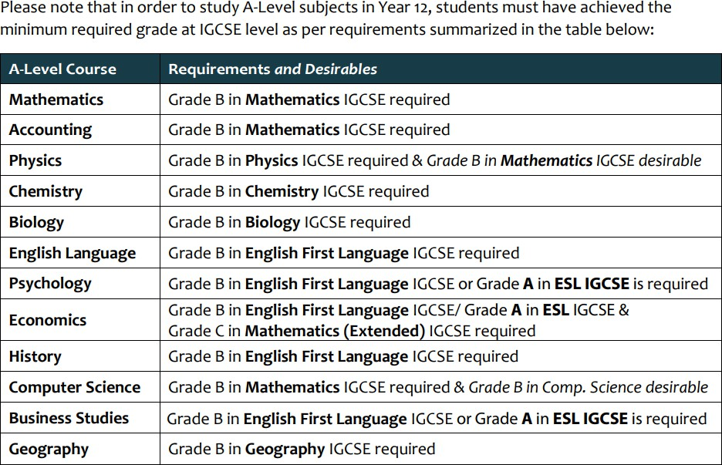

University Recognition of A-Levels
A-Level qualifications are globally recognised and accepted by universities in the UK and around the world. Parents and students are encouraged to consult with university admissions offices to confirm subject and grade requirements for their chosen degree pathways, as these may vary by institution and country.

Admissions Policy Statement for IBCP
RGSR welcomes applications from students of all nationalities who exhibit a commitment to academic excellence, personal growth, and global citizenship. The IBCP at RGSR is designed for students who are keen to develop both academic and career-related skills, fostering a balance between academic rigor and practical experience. The admissions process is conducted fairly, transparently, and without discrimination, adhering to our commitment to equal opportunity.

Admissions Criteria for IBCP
Applicants for the IBCP at RGSR should demonstrate a readiness for the challenges of an internationally focused program. Students are expected to have a solid academic foundation, as well as the motivation and interpersonal skills required for successful participation.
  - A minimum of 5 IGCSEs (or equivalent) at grade A*-C, including English and Mathematics.
  - Demonstrated commitment to personal and academic development.
  - Strong interpersonal and collaborative skills.
  - The ability to engage in reflective and independent learning.
Once enrolled in the Career-related Programme (CP), students are expected to remain in the programme for the full two-year duration. Transferring to the A-Level pathway or withdrawing from the CP mid-programme is not permitted. Any exceptional request to transfer or withdraw from the program will be reviewed on a case-by-case basis by the Head of Sixth Form, CP Coordinator, parents/legal guardians, and relevant academic staff, taking into account student wellbeing, academic continuity, subject availability, assessment requirements, and university/career pathways.

DP Course | Requirements and Desirables
Business Management (SL) | Grade C in English First Language IGCSE or Grade B in ESL IGCSE
Mathematics Applications and Interpretation (SL)  Mathematics Applications and Interpretation (HL) | Grade C or above in IGCSE Mathematics  Grade B or above in IGCSE Mathematics
Sports, Exercise and Health Science (SL) | Grade C in Biology IGCSE or/and Grade C in PE IGCSE

University Recognition of the IBCP
We recommend that all parents and students consult with their preferred universities to confirm recognition and acceptance of the International Baccalaureate Career-related Programme (IBCP) for their intended courses of study. University entry requirements may vary depending on country, institution, and chosen field of study.

Review and Communication
The Admissions Policy will be reviewed every two years to ensure it remains relevant and aligned with both IB standards and the needs of our school community. Updates to the policy will be communicated to all stakeholders via the school website and newsletters.

Appendices
Appendix A:
A-Level Overview and Student Profile
The A-Level programme is designed for students aged 16–19 who wish to pursue an in-depth, subject-specialist academic pathway that leads directly to university study. An ideal A-Level student is:
  - Academically focused and independent: They are motivated by deep subject study, capable of sustained effort in research, analysis, and extended written work.
  - Goal-oriented: They have clear aspirations for higher education or specific professional fields such as medicine, engineering, law, or business, and see A-Levels as a pathway to those goals.
  - Analytical and disciplined: They enjoy problem-solving, critical evaluation, and developing mastery in a small number of chosen subjects.
  - Resilient and self-managing: The A-Level structure requires consistent self-organisation, revision planning, and responsibility for independent learning across a two-year course.
  - University-ready: A-Level students gain rigorous academic preparation and transferable skills such as argumentation, evaluation, and communication that are highly regarded by universities worldwide.
The A-Level route best suits students who prefer depth over breadth, thrive in traditional academic study, and seek strong foundations for specialised university degrees.

Appendix B:
A-Level Orientation and Communication Procedures

Information Session for Students and Parents
  - Led by the Head of Sixth Form and A-Level subject leads.
  - Overview of the A-Level structure, assessment model, and grading system.
  - Explanation of subject selection, progression requirements, and alignment with university pathways.
  - Guidance on workload expectations, independent study habits, and assessment timelines.
  - Q&A opportunity for students and parents to clarify subject or course concerns.

Parent Guidebook
  - Distributed at the start of Year 12 and available digitally.
  - Includes key information on subject combinations, exam boards, grading scales, assessment schedules, university recognition, and school support systems.
  - Provides contact points for academic support, careers guidance, and pastoral matters.

Ongoing Communication
  - Regular progress updates through reports, parent consultations, and individual student mentoring sessions.
  - Coordination between subject teachers, tutors, and parents to ensure early support and intervention where needed.
The A-Level orientation and communication process aims to provide transparency, build shared understanding, and ensure that students and parents feel informed, supported, and engaged throughout the two-year programme.


Appendix C:
IBCP Overview and Student Profile
The International Baccalaureate Career-related Programme (IBCP) is designed for students aged 16–19 who are interested in combining academic study with practical, career-related learning. An ideal IBCP student is:
  - Motivated by real-world learning: They are eager to apply academic knowledge to practical and professional settings, bridging the gap between theory and practice.
  - Open to diverse pathways: IBCP students may be considering university, further education, apprenticeships, or direct entry into the workforce after graduation.
  - Reflective and responsible: They are ready to engage in personal and professional development, including service learning, reflective projects, and language development.
  - Globally minded and ethical: Through the IBCP core and the IB Learner Profile, students grow into principled individuals who can think critically and act with integrity.
  - Flexible and balanced learners: The IBCP offers a balance between academic rigor (via DP subjects) and career-related studies, making it ideal for students who want a more applied and balanced approach to education.
The IBCP is a good fit for students who are looking for a flexible, challenging, and meaningful educational experience that prepares them for success in higher education, professional training, and life beyond school.
Appendix D:
IBCP Orientation and Communication Procedures
Information Session for Students and Parents
  - Hosted by the IBCP Coordinator and relevant faculty members
  - Overview of the CP structure, including the CP Core, DP subjects, and Career-related Study (CRS)
  - Explanation of the differences between CP and other academic pathways (e.g., A-Levels, full IB Diploma)
  - Q&A session to address specific concerns or questions
Parent Guidebook and CP Guide: Includes detailed information about academic expectations, assessment, university recognition, and school support systems.

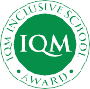




ACCREDITED
MEMBER

